Practical No. 2
Aim : WAP to display a message on screen.

Name : Danish Altaf Solkar | Class : CO - B
Enrolment no. : 24111590805 | Batch : 2

Code :-
name=input("Enter your name: ")
age=int(input("Enter your age: "))
course=input("Enter your course: ")
print("\n---User Details---")
print("Name : ",name)
print("Age : ",age)
print("Course : ",course)

OUTPUT :-
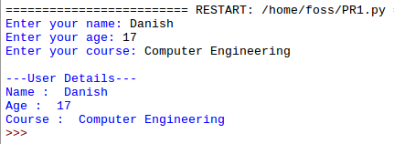

Process related  (30) | Product related  (20) | Total Marks  (50) | Signature

